**MENTOR EVALUATION**

Capstone Project:

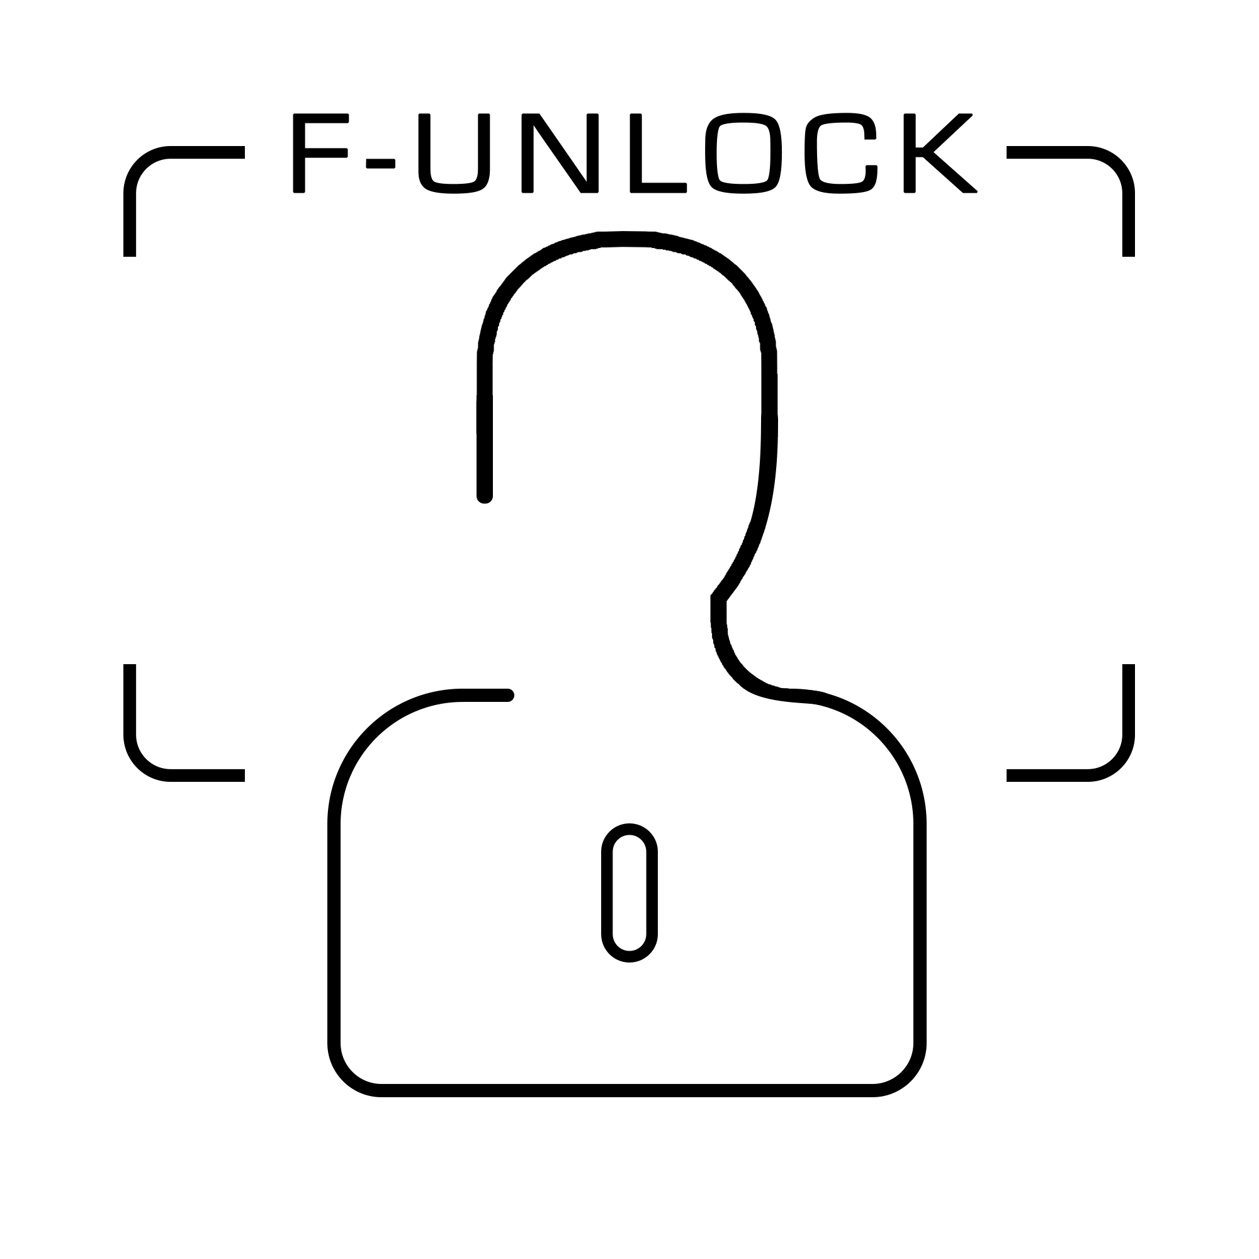**F-Unlock**

Submitted to:

*Dr. Sanmeet Kaur*

Submitted by:

|  |  |
| --- | --- |
| Abhishek Handa | 101503006 |
| Abhishek Salwan | 101503007 |
| Ajay Jindal | 101503016 |

**Table of Contents**

1. Use Case Diagram 3

2. Use Cases for F-Unlock 4

3. Tasks & Subtasks 10

4. Activity / Swim-Lane Diagram 12

5. Work Breakdown Structure 13

6. Gantt Chart 14

7. Functional Requirements 15

8. Non-Functional Requirements 15

# Use Case Diagram

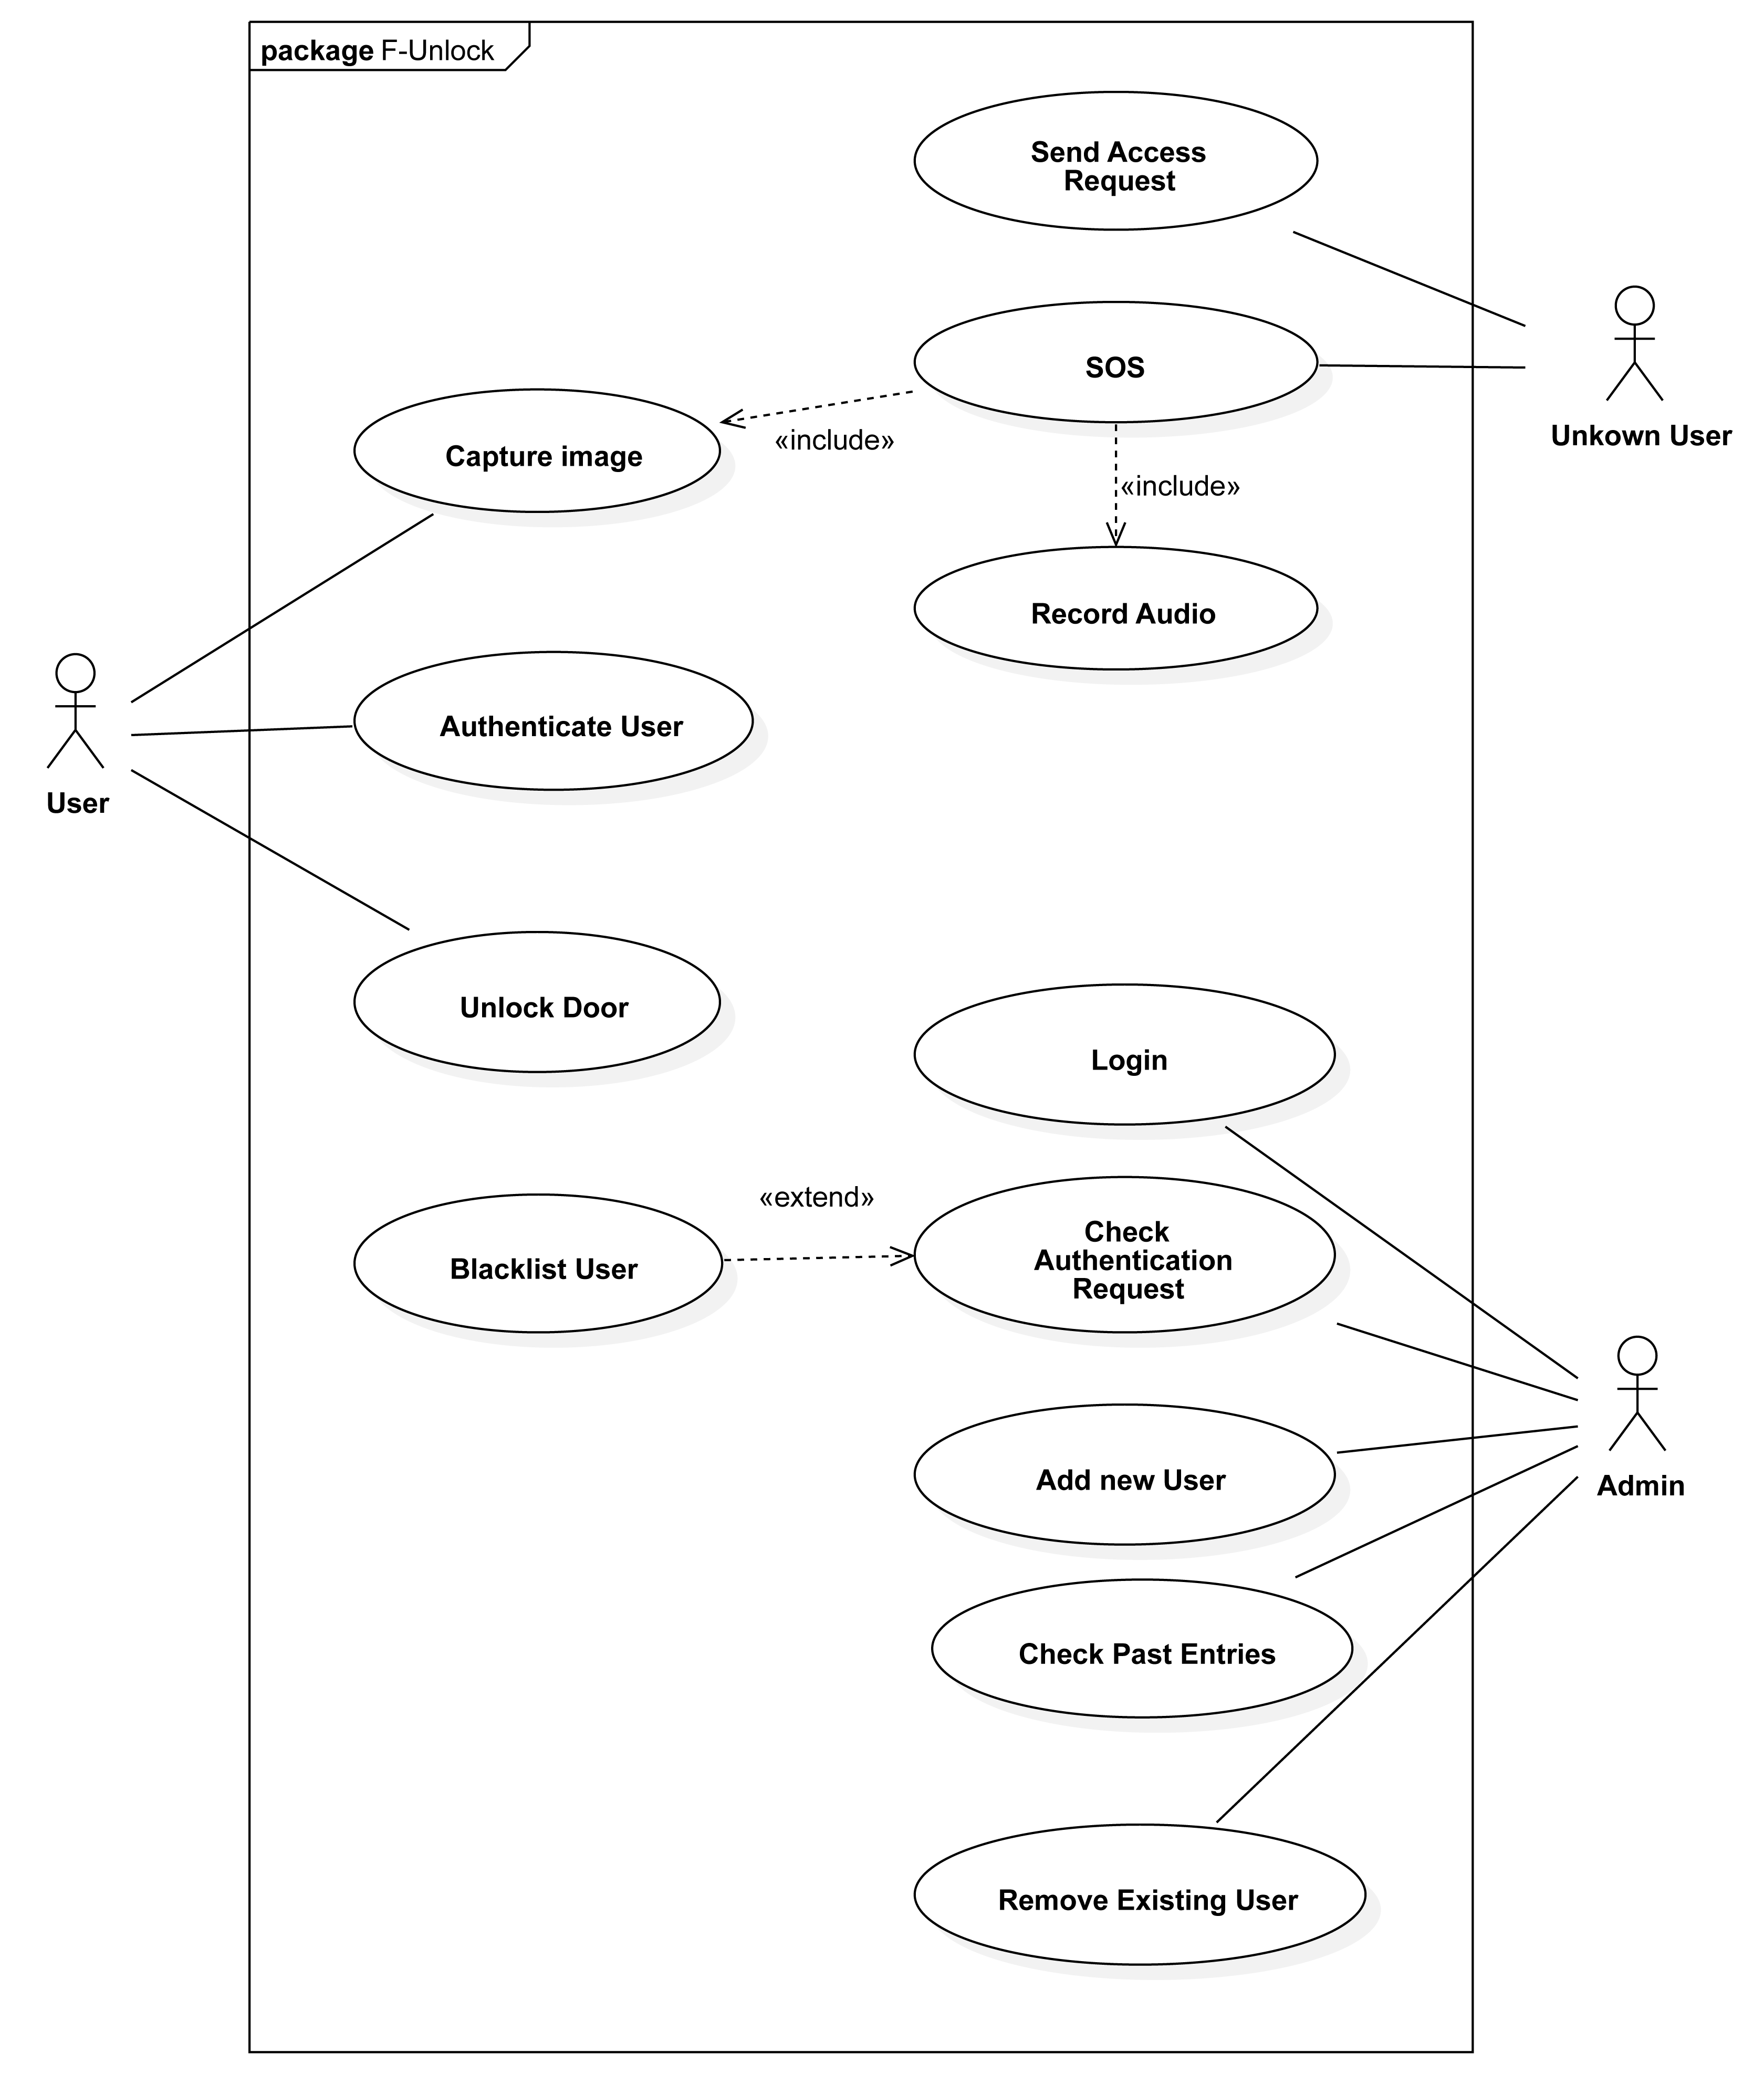

# Use Cases for F-Unlock

|  |  |
| --- | --- |
| Use Case ID: | 01 |
| **Use Case Name:** | **Send Access request** |
| Actor: | Unknown user |
| Description: | Request to the owner for access required through the door |
| Preconditions: | - |
| Postconditions: | Sends the request to owner’s mobile phone for authentication |
| Priority: | Medium |
| Frequency of Use: | Low |
| Normal Course of Events: | 1. Unknown user arrives 2. Requests access through the door 3. Proceeds the request to the owner |
| Exceptions: | - |
| Includes: |  |
| Special Requirements: | System working |
| Assumptions: | - |
| Notes and Issues: | - |

|  |  |
| --- | --- |
| Use Case ID: | 02 |
| **Use Case Name:** | **SOS** |
| Actor: | Unknown User |
| Description: | SOS emergency feature in case of natural calamities inside of the house. |
| Preconditions: | System is fully working & online. |
| Postconditions: | Alert the owner, updates the database. |
| Priority: | High |
| Frequency of Use: | Rarely in case of emergencies |
| Normal Course of Events: | 1. Unknown person asks for emergency access. 2. Device records audio message & image. 3. Remote alert onto owner’s mobile device. 4. Owner decides whether to allow or not |
| Exceptions: | Network failure to reach the owners. |
| Includes: | Capture Image  Record Audio |
| Special Requirements: | Higher efficiency, low latency |
| Assumptions: | Only to be used in case of emergencies |
| Notes and Issues: | False alarms can cause inconvenience |

|  |  |
| --- | --- |
| Use Case ID: | 03 |
| **Use Case Name:** | **Capture image** |
| Actor: | User |
| Description: | Captures the image for storing in database after detecting a granted or denied face. |
| Preconditions: | Camera is working |
| Postconditions: | Updates the database with a new picture.  Sends the alert the mobile device of the owner |
| Priority: | Medium |
| Frequency of Use: | Often (every time a human appears in front the camera) |
| Normal Course of Events: | 1. Detects a human 2. Captures the image 3. Dave to database |
| Exceptions: | Camera failure |
| Includes: | - |
| Special Requirements: | Better image quality, effective compression |
| Assumptions: | Captures only when a human is detects |
| Notes and Issues: | - |

|  |  |
| --- | --- |
| Use Case ID: | 04 |
| **Use Case Name:** | **Record Audio** |
| Actor: | - |
| Description: | Record audio for sos feature |
| Preconditions: | SOS is triggered |
| Postconditions: | Sends the audio recording to the owner for verification |
| Priority: | High |
| Frequency of Use: | Rarely in case of emergencies |
| Normal Course of Events: | 1. SOS feature is triggered 2. Records audio with mic 3. Save the recording the database 4. Send the audio the owner |
| Exceptions: | Mic stops working, unwanted external noises |
| Includes: | - |
| Special Requirements: | Ambient noise reduction |
| Assumptions: | Captures only when a human is detected |
| Notes and Issues: | - |

|  |  |
| --- | --- |
| Use Case ID: | 05 |
| **Use Case Name:** | **Authenticate User** |
| Actor: | User |
| Description: | Matches the captured face with the database of trusted faces |
| Preconditions: | Human face is detected & recognized |
| Postconditions: | Forwards the request to the classifier for final decision |
| Priority: | High |
| Frequency of Use: | Everytime a face is detected |
| Normal Course of Events: | 1. Human face is detected 2. Feature extraction 3. Comparison with the existing database of trusted face 4. Generates accuracy of similarity |
| Exceptions: | System failure, bugs preventing the flow of execution |
| Includes: | - |
| Special Requirements: | Efficiency of algorithms, better accuracy |
| Assumptions: | Human face is detected |
| Notes and Issues: | - |

|  |  |
| --- | --- |
| Use Case ID: | 06 |
| **Use Case Name:** | **Unlock door** |
| Actor: | User |
| Description: | Relay mechanism acts to open the door |
| Preconditions: | Permission is granted |
| Postconditions: | Remain in the state of being unlocked for defined |
| Priority: | High |
| Frequency of Use: | Low, only when trusted is recognized |
| Normal Course of Events: | 1. Permission granted 2. Relay mechanism acts to open the door 3. Success alert sound |
| Exceptions: | - |
| Includes: | - |
| Special Requirements: | - |
| Assumptions: | - |
| Notes and Issues: | - |

|  |  |
| --- | --- |
| Use Case ID: | 07 |
| **Use Case Name:** | **Login** |
| Actor: | Admin |
| Description: | Login into the account of the administrator |
| Preconditions: | - |
| Postconditions: | Allows the administrator to change working of the product & maintenance. |
| Priority: | High |
| Frequency of Use: | Low |
| Normal Course of Events: | 1. Admin provides info for login 2. Verification with the database 3. Login successful/denied |
| Exceptions: | Wrong information, unknown character inputs |
| Includes: |  |
| Special Requirements: | Faster server speed, remote access |
| Assumptions: | - |
| Notes and Issues: | - |

|  |  |
| --- | --- |
| Use Case ID: | 08 |
| **Use Case Name:** | **Check authentication request** |
| Actor: | Admin |
| Description: | Allows the admin/owner to verify the authentication request remotely. |
| Preconditions: | Admin is logged in |
| Postconditions: | Send the verdict of the admin of grant or denied |
| Priority: | High |
| Frequency of Use: | Medium |
| Normal Course of Events: | 1. Admin receives the info authentication request 2. Validation by the admin/owner 3. Send back the verdict to the system. |
| Exceptions: | - |
| Includes: | - |
| Special Requirements: | Extend blacklist user |
| Assumptions: | - |
| Notes and Issues: | - |

|  |  |
| --- | --- |
| Use Case ID: | 09 |
| **Use Case Name:** | **Blacklist user** |
| Actor: | - |
| Description: | Function that permanently blacklists a specific user from accessing the door. |
| Preconditions: | Admin checks the authentication request |
| Postconditions: | Add user to blacklist in database |
| Priority: | Medium |
| Frequency of Use: | Low |
| Normal Course of Events: | 1. Admin requests a specific person to be blacklisted 2. Add the person into blacklist in database |
| Exceptions: | Database errors |
| Includes: | - |
| Special Requirements: | - |
| Assumptions: | Sufficient available space for database entry |
| Notes and Issues: | - |

|  |  |
| --- | --- |
| Use Case ID: | 10 |
| **Use Case Name:** | **Add new user** |
| Actor: | Admin |
| Description: | Add a new trusted user |
| Preconditions: | - |
| Postconditions: | Updates database with a new trusted face & it’s data |
| Priority: | High |
| Frequency of Use: | Low |
| Normal Course of Events: | 1. Admin requests a new user entry 2. System asks for necessary requirements 3. Face feature capture/scan 4. Addition of new data into database |
| Exceptions: | Database memory error |
| Includes: | - |
| Special Requirements: | - |
| Assumptions: | - |
| Notes and Issues: | - |

|  |  |
| --- | --- |
| Use Case ID: | 11 |
| Use Case Name: | Check Past Entries |
| Actor: | Admin |
| Description: | View the log of all the past allowed entries |
| Preconditions: | Admin is logged in |
| Postconditions: |  |
| Priority: | Medium |
| Frequency of Use: | Low |
| Normal Course of Events: | 1. Admin requests the log of entries 2. System generates database request 3. Fetch the data from server 4. Display the log data to admin |
| Exceptions: | Server connection issue |
| Includes: | - |
| Special Requirements: | - |
| Assumptions: | Connected to internet |
| Notes and Issues: | - |

|  |  |
| --- | --- |
| Use Case ID: | 12 |
| Use Case Name: | Remove Existing user |
| Actor: | Admin |
| Description: | Delete a trusted user from database |
| Preconditions: | Admin is logged in |
| Postconditions: | Updates database after removing all the data of that particular user |
| Priority: | Medium |
| Frequency of Use: | Low |
| Normal Course of Events: | 1. Admin requests removal of a user 2. System asks for necessary permissions 3. Fetch the details of that user 4. Confirmation for removal 5. Delete the data from the database & server |
| Exceptions: | User data not found |
| Includes: | - |
| Special Requirements: | - |
| Assumptions: | User is present |
| Notes and Issues: | - |

# 3. Tasks & Subtasks

**1. Face Recognition Software:** The face recognition software is to recognise the face of the user and provide access to the room by unlocking the door. It uses camera detect the face and perform feature extraction and image classification.

1. **Face Detection**-:Human Face will be detected from an input image. Face detection went mainstream in the early 2000's when Paul Viola and Michael Jones invented a way to detect faces that was fast enough to run on cheap cameras. However, much more reliable solutions exist now. We’re going to use a method invented in 2005 called Histogram of Oriented Gradients — or just HOG for short.
2. **Normalize face landmarks**-:In a naive implementation there can be four separate convolutional neural networks (convNet) each responsible for each facial landmark.  
   A more efficient approach would be to share the convolutional (conv) features and add a fully connected neural network at the end with a 4-way softmax output layer, let's call that network, the landmark detector. The four softmax outputs provide 4 probabilities corresponding to the 4 landmarks respectively. Afterwards, low confidence detections can be threshold out and then apply non-maxima suppression (NMS) algorithm on the remaining detections so as to keep a single strongest detection around each landmark.
3. **Feature Extraction**-:It is not easy to extract features from facial images. Many factors such as, facial expression, imaging conditions, occlusion of facial features and presence or absence of facial elements such as, moustaches, beards, and glasses, that affects the performance of the algorithm.
4. **Facial Classification**-:We can do this by using any basic machine learning classification algorithm. We’ll use a simple linear SVM classifier, but lots of classification algorithms could work. All we need to do is train a classifier that can take in the measurements from a new test image and tells which known person is the closest match. Running this classifier takes milliseconds. The result of the classifier is the name of the person!

**2. Permission Request:** The new user can send the request to admin to unlock the door. The admin can decide whether to accept the request and give one time or permanent access rights. The admin can give permanent access rights by adding the new user. Permission request can also be used by new user in case of emergency situations by activating the SOS feature.

1. **Making Request-:**The locking system will be connected to the Wi-Fi of home and any new user can request to access the lock by sending his pick along with an audio message to the admin.
2. **Sending Request-:** After making the request successfully new user will need to send the request to the admin. Depending upon the picture and audio recorded sent, admin can make the decision whether to accept the request or reject it.
3. **Adding Extra features-:** Depending on the situation of SOS like fire etc., admin will also have option to make call to police, ambulance, Fire Dept. etc.

**3. Add New User:** The admin has the rights to add new user either on temporary or permanent basis. The admin can check the authentication requests from mobile or web applications which is connected.

# 4. Activity / Swim-Lane Diagram

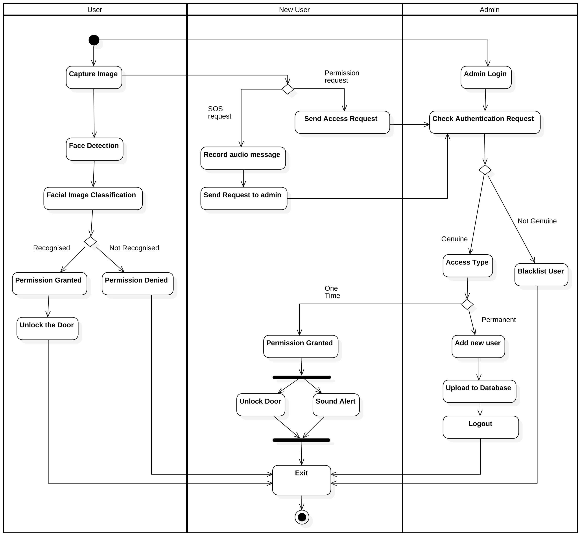

# Work Breakdown Structure

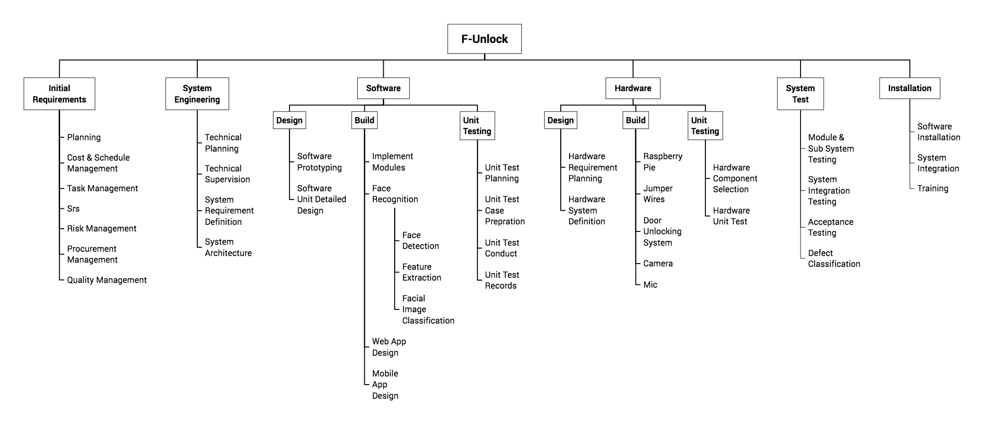

# Gantt Chart

|  |  |  |  |
| --- | --- | --- | --- |
| Task Name | Start | End | Duration (days) |
| Planning & SRS | 04/02/18 | 25/02/18 | 21 |
| Schedule & Task Management | 03/03/18 | 20/03/18 | 17 |
| System Engineering | 25/03/18 | 10/04/18 | 16 |
| Software Design & Build | 11/04/18 | 05/05/18 | 24 |
| Hardware Design & Build | 25/05/18 | 30/06/18 | 36 |
| System Testing | 01/07/18 | 30/07/18 | 29 |
| Product Refinement | 01/08/18 | 30/08/18 | 29 |
| Product Installation | 01/09/18 | 16/09/18 | 15 |
| Documentation | 17/09/18 | 17/10/18 | 30 |
| Customer Survey & Feedback | 18/10/18 | 30/10/18 | 12 |
| Final Presentation Preparations | 01/11/18 | 01/12/18 | 30 |

# Functional Requirements

1. **Face Recognition:**

Face Recognition software consists of recognising the image of the user using camera. If the user is recognised then the software sends the signal through Raspberry Pi to relay to perform the door unlock operation.

1. **Power Supply**: The power supply is required for Raspberry Pi loaded with face recognition software for the security system to work.
2. **Raspberry Pi**: Raspberry Pi is for running the face recognition software which will grant access to security system.
3. **Internet Connectivity**: Internet Connectivity is required to send the permission request to the server which will be then validated by the admin.
4. **Relay Operation**: After the face recognition step the relay operation is to be performed in case the face is recognised.
5. **Camera**: Camera is for taking the image of the user and perform face recognition afterwards.

# Non-Functional Requirements

1. **Reliability:**

System should be reliable enough with high accuracy rate. Also it must not get unlocked using image of a person instead of actual person. It must not get unlocked by any unknown person which is not in the database.

1. **Response time:**

System should have very less response time and should unlock the door quickly on identifying a correct user. It should take small processing time.

1. **Accessibility:**

The website and mobile application should be accessible to user at all times. The interface of website and mobile application should be easy to use for the user.

1. **Stability:**

The system should be stable enough with minimum number of resets required. It should have exception handling mechanism and should avoid getting in hanged state.

1. **Maintainability:**

The system should be easy to maintain over long time .Any modifications required after deployment should be easy to make.